Experiment no: 1 Date: 1/08/2024

**Aim:** To review the principles and syntax of C and Java programming

**Software Language**: C and Java

**Theory:**

**C programming:**

C programming is a powerful general-purpose language that was developed in the early 1970s by Dennis Ritchie at Bell Labs. C provides low-level access to memory through the use of pointers and allows for direct manipulation of hardware. It is widely used in system programming, developing operating systems, and embedded systems. C's syntax and concepts have influenced many other modern programming languages, making it a fundamental language for computer science education and a crucial skill for developers.

**Java programming:**

Java programming is a versatile, object-oriented language developed by Sun Microsystems in the mid-1990s. Known for its "write once, run anywhere" capability, Java allows developers to create cross-platform applications that can run on any device with a Java Virtual Machine (JVM). Its robust libraries, strong memory management, and security features make it a popular choice for building enterprise-level applications, web services, and Android apps. Java's syntax and structure promote code readability and reusability, making it an essential language for modern software development.

Programs:

1. Write a program to check whether a number is prime or not

* Write the code in C inside void main function
* Write the code in C by creating a separate function isprime ().
* Write the code in Java

1. Write a program to count number of characters and digits in a string

* Write the code in C inside void main function
* Write the code in Java

1. Write a program to traverse and print the array
   * + Write the code in C inside void main function (Initialize the array in the code)
     + Write the code in C inside void main function (Take input from user)

* Write the code in Java inside the main class

Code:

**1.**

* **Write the code in C inside void main function**

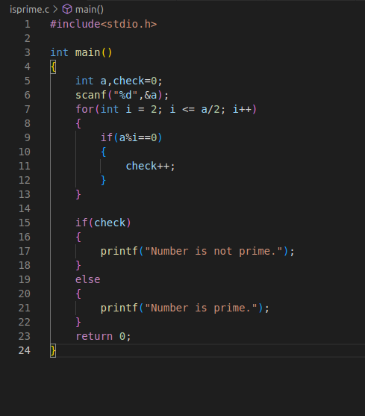

* Output :



* **Write the code in C by creating a separate function isprime ().**

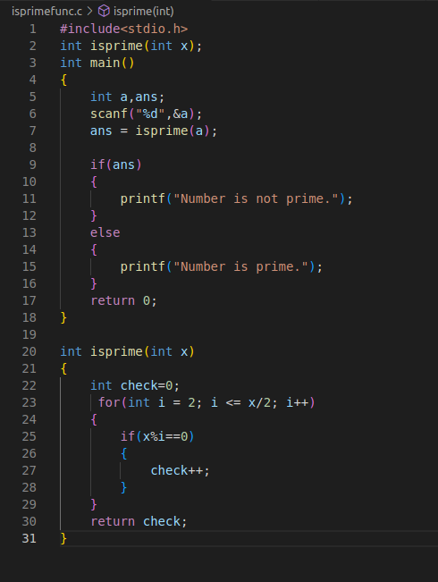

**Output:**





* **Write the code in Java**

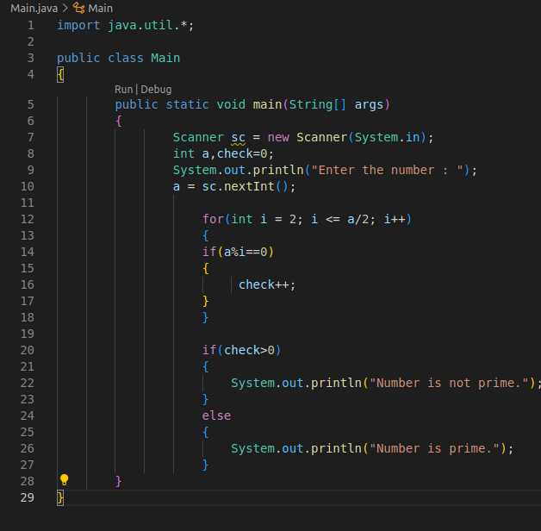

**Output :**





**2.**

* **Write the code in C inside void main function**

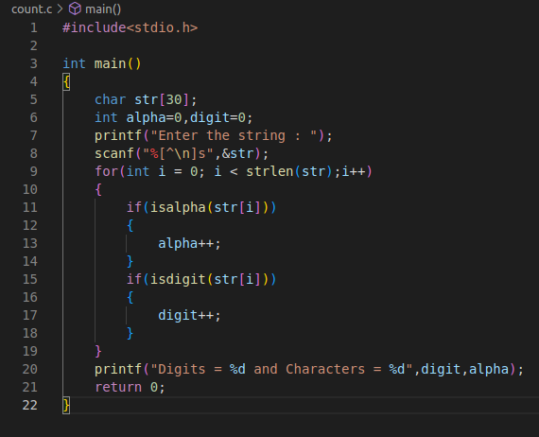

**Output :**

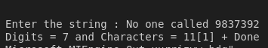

Note : [1] + done is just part of running code on vscode. Not output

* **Write the code in Java**

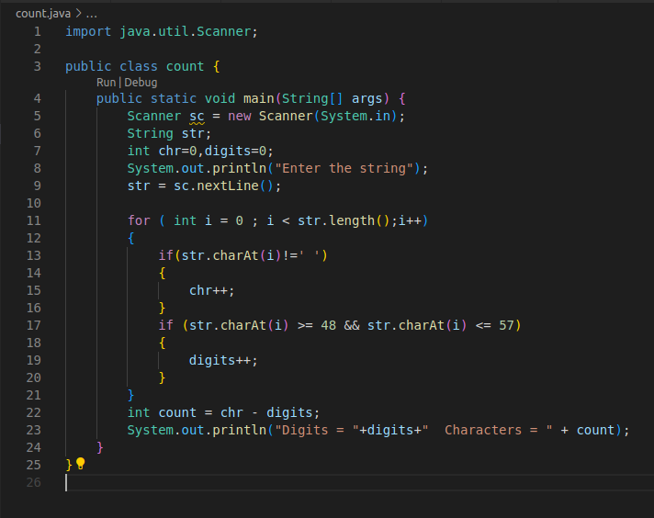

Output:



3.

* + - Write the code in C inside void main function (Initialize the array in the code)

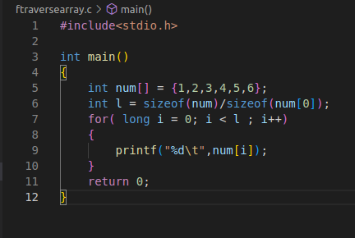

Output :



* + - **Write the code in C inside void main function (Take input from user)**

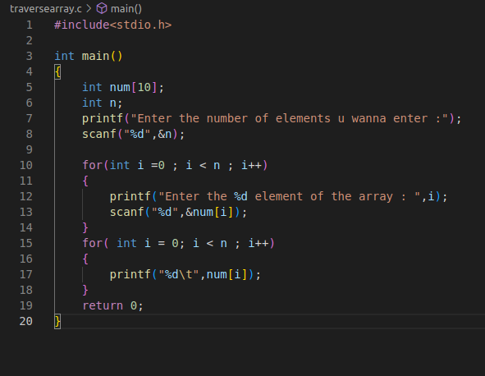

**Output:**

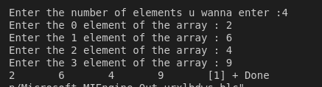

* **Write the code in Java inside the main class**

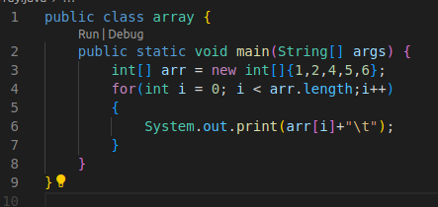

**Output :**



**Result and conclusion :** Thus, we revised previous coding concepts of C and Java and solved basic question.